The International Margaret Cavendish Society Presents
The 12th Annual Biennial Conference
Margaret Cavendish:
Reception and Representations

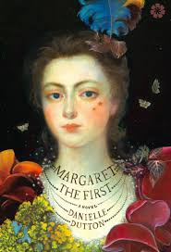
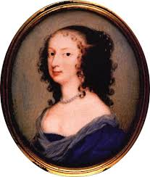

Bates College, Lewiston, Maine
June 22-24, 2017

Carolyn Merchant, Plenary Address: “Margaret Cavendish: Natural Philosopher and Feminist"
Danielle Dutton, Reading from her novel, Margaret the First

https://www.margaretcavendishsociety.org/

